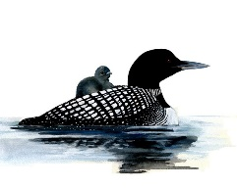
RIDEAU LAKES EARLY LEARNING CENTRE
29 Main Street | P.O. Box 154 | Elgin, ON K0G 1E0
rlelc@hotmail.com | 613-359-0002

Childcare Readiness
- Arrange a visit with in-home caregivers while you are at home or when you need childcare for a short time.
- Visit the center or home with your child before beginning care. Show your child that you like and trust the caregiver.
- Check with the caregiver or center staff about the best time of the month or year for children to begin attending the program.
- Allow your child to carry a reminder of home to childcare. A family photograph or small toy can be helpful.
- Talk with your child about childcare and the caregiver.
- Read books about childcare. (Check with your local library.)

